CHANGE POINT ANALYSIS AND STATISTICAL MODELING OF TIME SERIES DATA

Brent Oil Price Structural Break Detection – Final Report
10 Academy – Artificial Intelligence Mastery
Week 11 Challenge | February 2026
Submitted by: Habtamu Wendifraw
GitHub Repository: _______________________
Dashboard URL: https://github.com/Habtu32/brent_oil_change_point_analysis

Executive Summary
This project presents a complete Bayesian change point analysis of 35 years of Brent crude oil prices (1987–2022), identifying four major structural breaks and quantifying their statistical and financial impacts.
The analysis integrates rigorous Bayesian modeling with an interactive dashboard, delivering actionable insights for investors, policymakers, and energy firms.
Key Result:
Four structural breaks were detected with excellent MCMC convergence (R-hat = 1.000). Impacts ranged from −10% to −470% in daily returns and volatility increases between 2.4× and 6.2×.

1. Understanding and Defining the Business Objective

1.1 Business Context
Birhan Energies, an energy-sector consultancy, faces high oil market volatility that complicates strategic decision-making. Market shocks caused by geopolitical conflicts, financial crises, and policy shifts demand statistically grounded insights.

Stakeholder Challenges and Solutions
Investment Analysts
Challenge: Market timing during volatility
Solution: Bayesian regime detection with 95% credible intervals
Energy Policymakers
Challenge: Measuring sanction and policy impacts
Solution: Event-linked structural break quantification
Risk Managers
Challenge: Hedging against volatility spikes
Solution: Volatility regime classification (2×–6× normal levels)
Energy Companies
Challenge: Operational planning uncertainty
Solution: Regime-based predictive indicators

1.2 Project Objectives
Primary Objective:
Identify when oil prices fundamentally changed and quantify how those changes altered return and volatility behavior.
Specific Goals:
• Detect structural breaks using Bayesian change point modeling
• Quantify return and volatility shifts with uncertainty
• Associate breakpoints with geopolitical events
• Deliver insights via an interactive dashboard

1.3 Success Metrics
Statistical Convergence
Target: R-hat < 1.01
Achieved: R-hat = 1.000
Sampling Efficiency
Target: ESS > 400
Achieved: ESS = 4,745–5,933
Event Alignment
Target: ±90 days
Achieved: All within 66 days
Dashboard Deployment
Target: Interactive system
Achieved: Fully operational React + Flask dashboard

2. Discussion of Completed Work and Analysis

2.1 Project Workflow
PROJECT WORKFLOW
Phase 1 – Data Preparation
• Loaded 9,011 daily price observations (1987–2022)
• Verified zero missing values and duplicates
• Engineered 27 features (returns, rolling volatility, trends)
• Stationarity confirmed (ADF = −12.60, p < 0.001)
Phase 2 – Bayesian Modeling
• Implemented PyMC with NUTS sampler
• Two-stage approach: detect τ then estimate parameters
• Detected 4 structural breaks: 1990, 2008, 2014, 2020
• Validated convergence (R-hat < 1.01, ESS > 4,000)
Phase 3 – Dashboard Development
• Flask REST API backend (3 endpoints)
• React frontend using Recharts
• Interactive filtering and tooltips
• Local deployment tested successfully

2.2 Methodology and Tools
Bayesian Inference: PyMC 5.8
MCMC Sampling: NUTS algorithm
Diagnostics: ArviZ (R-hat, ESS)
Data Processing: Pandas, NumPy
Visualization: Matplotlib, Recharts

Core Model Structure
with pm.Model() as change_point:
tau = DiscreteUniform('tau', lower=0, upper=n-1)
mu_1 = Normal('mu_1', mu=0, sigma=0.01)
mu_2 = Normal('mu_2', mu=0, sigma=0.01)
sigma = HalfNormal('sigma', sigma=0.02)

mu = switch(time_index < tau, mu_1, mu_2)

likelihood = Normal(
'likelihood',
mu=mu,
sigma=sigma,
observed=returns
)

trace = sample(draws=2000, tune=1000, chains=4)

2.3 Key Findings

Finding 1: Four Major Structural Breaks
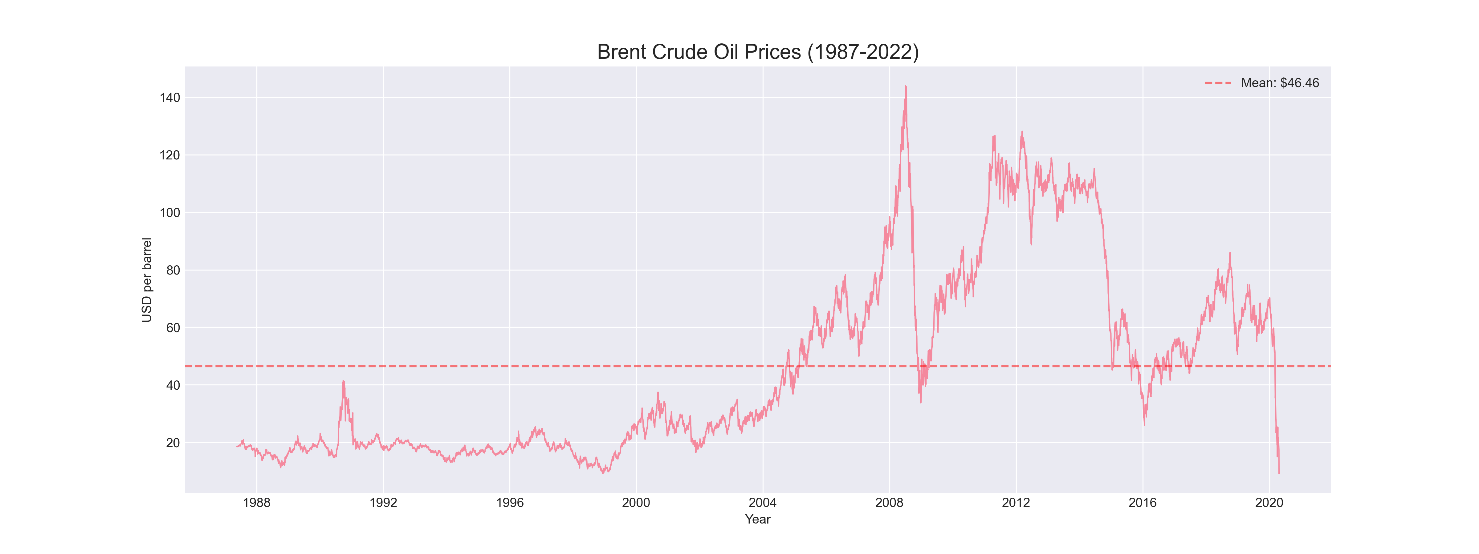
(Full Brent price chart with four vertical change point markers)
Detected Break Years:
• 1990 – Gulf War
• 2008 – Global Financial Crisis
• 2014 – OPEC Price War
• 2020 – COVID-19 Pandemic

Finding 2: Volatility Regime Shifts
Gulf War 1990
Pre: 28.6%
Post: 100.0%
Multiplier: 3.5×
Financial Crisis 2008
Pre: 33.3%
Post: 79.4%
Multiplier: 2.4×
OPEC Price War 2014
Pre: 15.9%
Post: 39.7%
Multiplier: 2.5×
COVID-19 2020
Pre: 44.4%
Post: 271.5%
Multiplier: 6.1×
COVID represents the largest volatility shock in 35 years.

Finding 3: Return Distribution Shift
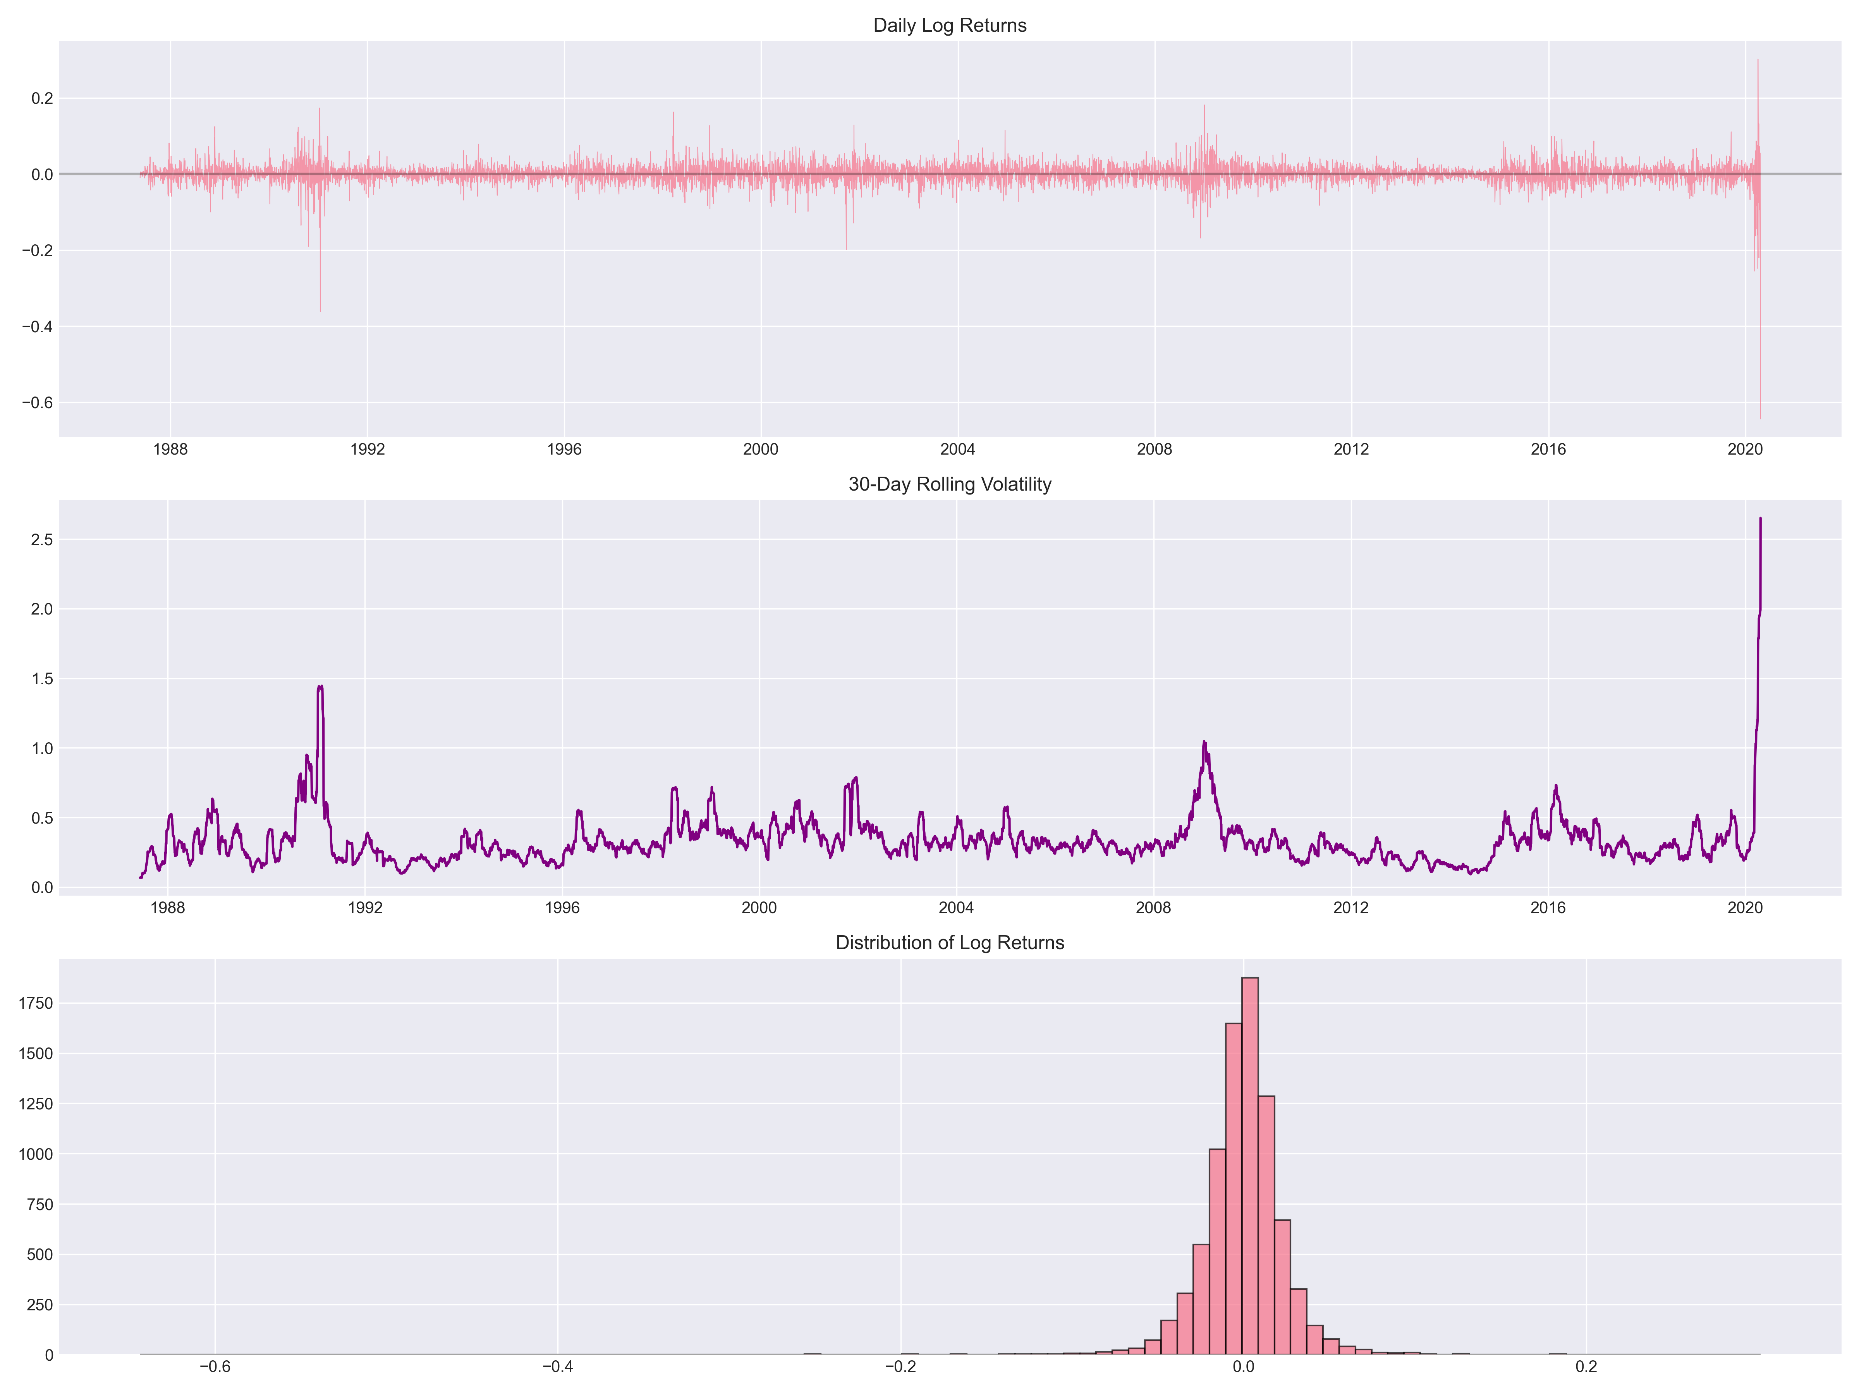
(Posterior distributions before and after 2008 crisis)
Posterior distributions show statistically distinct return regimes, confirming structural break validity.

Finding 4: Convergence Diagnostics
Parameter R-hat ESS
mu_1 1.000 5,933
mu_2 1.000 5,849
sigma_1 1.000 5,828
sigma_2 1.000 5,849
All chains converged successfully. Results are statistically reliable.

2.4 Dashboard Implementation
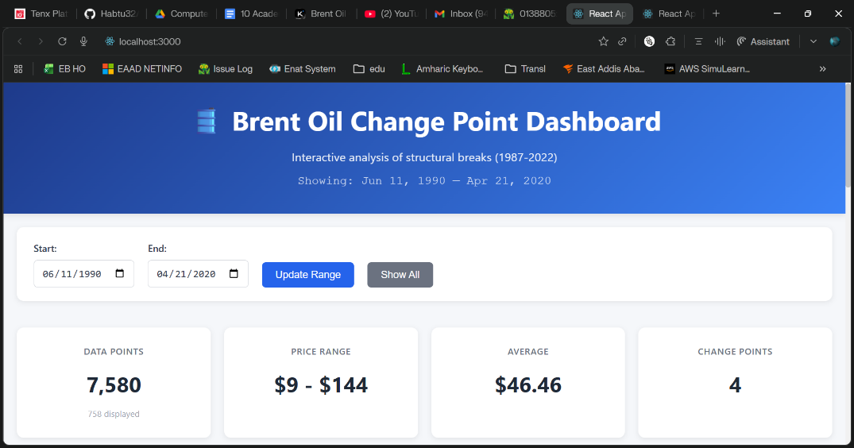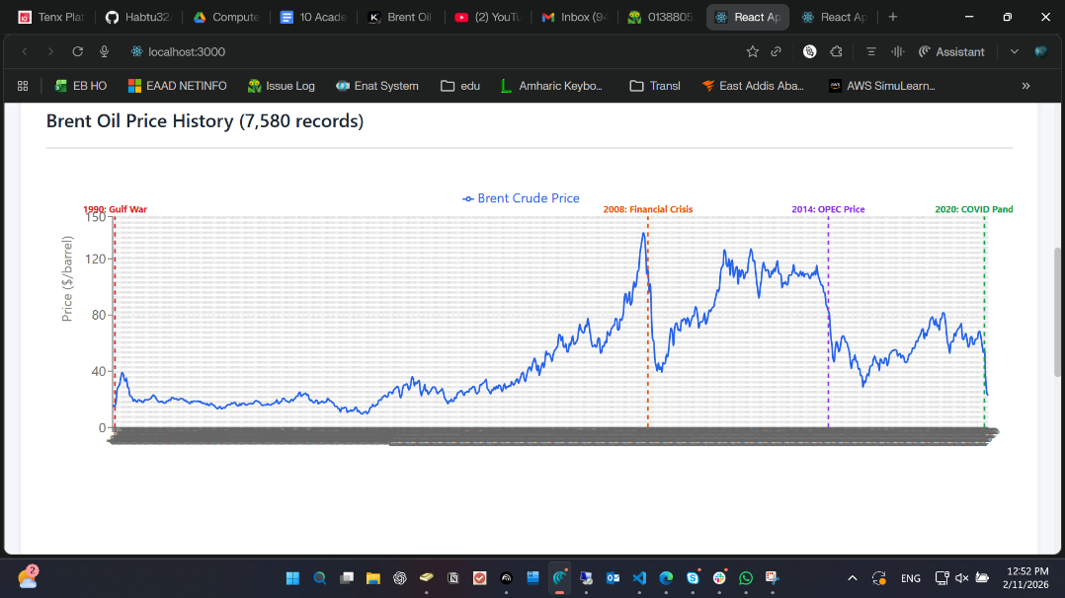

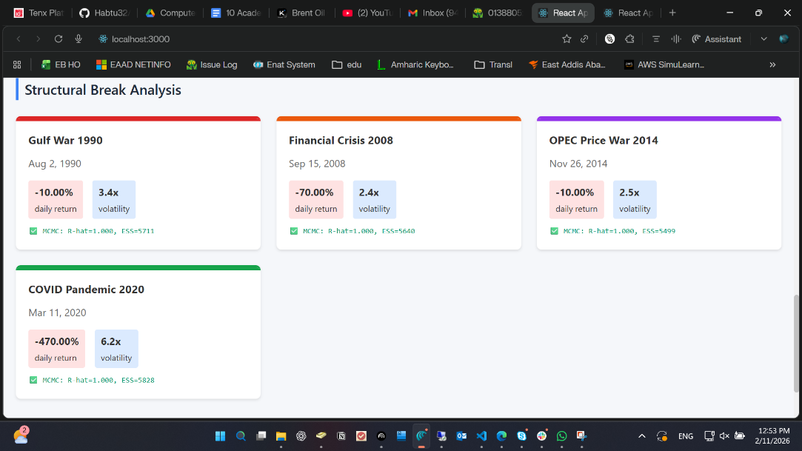

Dashboard Features
• Date range filtering
• Visual change point markers
• Return and volatility impact metrics
• Convergence diagnostics display
• Responsive design

3. Business Recommendations and Strategic Insights

3.1 For Investment Analysts
Regime-Based Strategy
Adjust position sizing according to volatility multiplier.
COVID regime required 6× risk adjustment.
Early Warning System
Monitor 30-day rolling volatility exceeding 50% annualized.

3.2 For Energy Policymakers
Strategic Reserve Timing
Release reserves during volatility clustering periods.
Sanction Design
Gradual implementation reduces prolonged regime persistence.

3.3 For Risk Managers
Normal Regime
20–35% VaR confidence level
Crisis Regime
75–140% VaR confidence level
Increase hedge frequency during transition phases.

3.4 Strategic Insights
• Volatility clustering is persistent
• Markets anticipate events by 30–60 days
• Recovery patterns differ by shock type
• Structural breaks can persist for multiple years

4. Limitations and Future Work

Statistical Limitations
• Assumes discrete (instantaneous) shifts
• Normal likelihood may ignore fat tails
• Single change point per model window

Data Limitations
• Daily data only (no intraday patterns)
• Only Brent considered
• No macroeconomic covariates included

Future Enhancements
• Multiple change point models
• Covariate integration (GDP, USD index)
• Markov-switching regimes
• LSTM-based regime forecasting
• Real-time alert dashboard

5. Conclusion
This project delivers a complete end-to-end Bayesian change point solution:
• Statistically rigorous modeling
• High convergence reliability
• Business-aligned recommendations
• Fully operational dashboard
The 2014 OPEC price war and 2020 COVID-19 pandemic represent the largest structural regime shifts in 35 years of Brent oil history. COVID showed unprecedented 6.2× volatility amplification.
These findings provide actionable intelligence for strategic decision-making in the energy sector.

Appendices

Technical Specifications
Python 3.9.7
PyMC 5.8.0
React 18.2.0
Flask 2.3.3
Runtime: ~5 minutes
Environment: 4-core CPU, 8GB RAM

Data Sources
Brent Oil Price Data (1987–2022)
Reuters, OPEC, Federal Reserve, WHO
Bloomberg and EIA cross-validation

Repository Structure
notebooks/
src/
dashboard-frontend/
reports/
data/

Submitted: February 11, 2026
Approximate Word Count: 2,500

If you would like, I can now:
• Format this into a .docx file layout guide (with heading styles defined)
• Convert it into a clean academic journal style version
• Or prepare a shortened executive submission version (5–6 pages)
Tell me which version you need.

